Part Number - 51-20982

Installation and Care for the Polaris General 1000 Crew Soft Door Kit

Caution: Do not smoke inside the cab or expose the enclosure to direct flames. Cab is Flammable.

Be sure to read these instructions thoroughly before opening and installing the enclosure. The installation is best done when the temperature is 70 degrees F. or warmer. The temperature affects the adhesive Velcro, if conditions prevent installing in warmer weather it helps to store the adhesive Velcro at room temperature prior to installation.

- Carefully open the carton and remove the rolled-up Cab Enclosure on a large flat surface that is clean and free of dirt or other material that may soil or scratch the windows of the Cab. Check over the parts included in the carton with the parts list shown below:

Velcro Hook Strips
Qty | Length
4 | 6 inches
2 | 9 inches
4 | 10 inches
2 | 12 inches
2 | 15 inches
2 | 18 inches
4 | 20 inches
2 | 22 inches
2 | 24 inches
2 | 33 inches

- Begin by Cleaning roll cage from front to back along the outside edges of the doors. It helps but is not necessary to remove the plastic. Next, attach a series of adhesive Velcro strips around the roll cage. Starting from the front the first strip should begin at the weld spot just above the bolts. 1) 22” 2) 24” 3) 33” 4) 12” 5) 18” 6) 6”

- Next place the adhesive Velcro strips along the top outside edges of the factory doors. The following order is the lengths from front to back. 1) 6” 2) 10” 3) 9” 4) 15” 5) 20” 6) 10”

- The following pictures show how this should look after all the Velcro is installed.

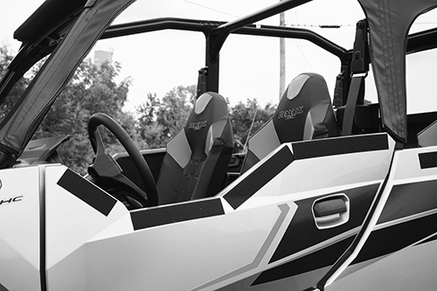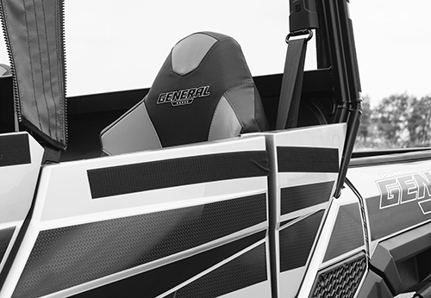

Cleaning and Storage Recommendations:

- Before removing the Cab for storage, make sure it is very clean in order to prevent scratching of the window panels. Clean with a soft rag or sponge using a mild liquid detergent soap and warm water solution. Never rub the windows with a dry cloth or rag! Let the Cab dry thoroughly before attempting to roll for storage.

- It is important that the Cab be rolled up for storage rather than folding. Folding will cause damage to the windows!!! Carefully roll up the Cab similar to the way it was when it was packed at the factory. On a large, clean and flat surface, fold the doors over the rear panel first, then, interleave the top and windshield on top of the doors. Begin rolling the Cab into a roll approximately 8 inches in diameter. Put the rolled Cab back into the carton for storage at a normal room temperature. It is best not to expose the Cab to either extreme hot or cold temperatures when storing.

If you have any questions, comments, need assistance, or are missing parts, please contact us by one of the methods below.

WARNING: This product contains a chemical known to the State of California to cause cancer. For more information, go to www.P65Warnings.ca.gov.

