Part number - 51-20985

Installation and Care for CF Moto U-Force 1000 Soft Door Kit

Caution: Do not smoke inside the cab or expose the enclosure to direct flames. Cab is Flammable.

Be sure to read these instructions thoroughly before opening and installing the enclosure. The installation is best done when the temperature is 70 degrees F. or warmer. This is to allow the Velcro to stick to the roll cage better, if you must install outside in the cold it will help to warm the Velcro inside at room temperature until ready to install.

- Carefully open the carton and remove the rolled up Cab Enclosure on a large flat surface that is clean and free of dirt or other material that may soil or scratch the windows of the Cab.

- Check over the parts included in the carton with the parts list shown below:

1" Adhesive Velcro Strip
2 each | 10 inches
2" Adhesive Velcro Strip
2 each |  | 29 inches
2 each |  | 26 inches
2 each |  | 18 inches
2 each |  | 5 inches

Snap Studs 24 each (2 extra )
Door Panels 2 each

- Begin by Cleaning the roll cage and plastic that surrounds the doors. Using rubbing alcohol is preferable. This step is very important for the Velcro strips to properly adhere.

- Now start installation by placing the 2" adhesive Velcro strips around the outside edges of the upper door frame. Starting at the front of the frame just above the rear view mirror, place the 26" strip as shown in the photo below.

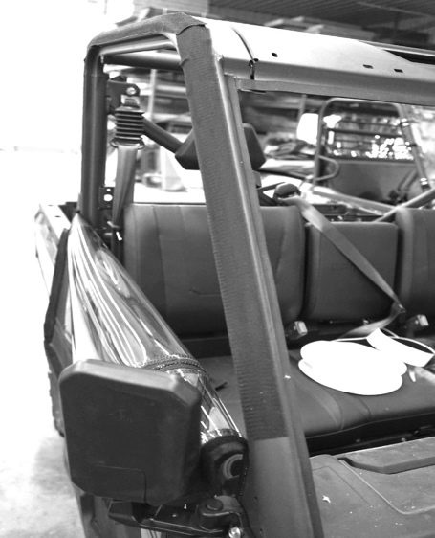
- Next place the 29" strip across the top of the frame as shown below.

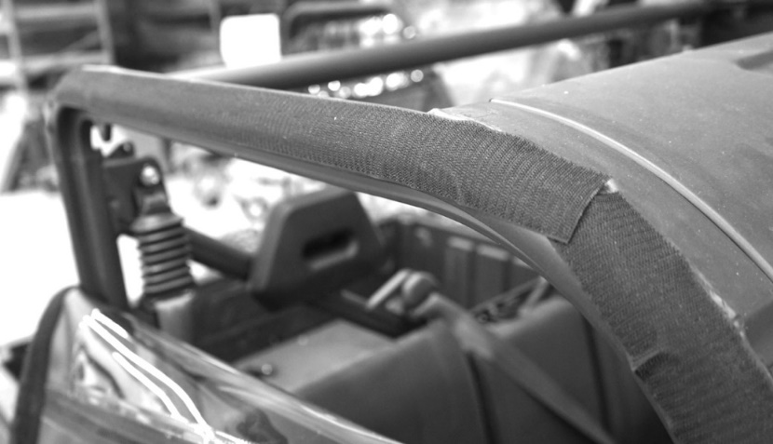

- Next place another 18" strip down the rear bar as shown below.

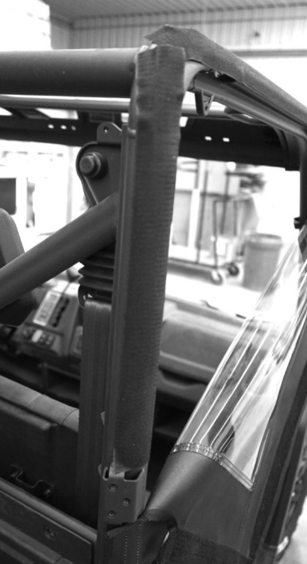

- Next place the 5" strip just below the bracket along the back of the roll cag

- Last piece of Velcro will be the 10” strip that is 1” wide. This goes on the frame just behind the rear-view mirror as shown in the photo below.
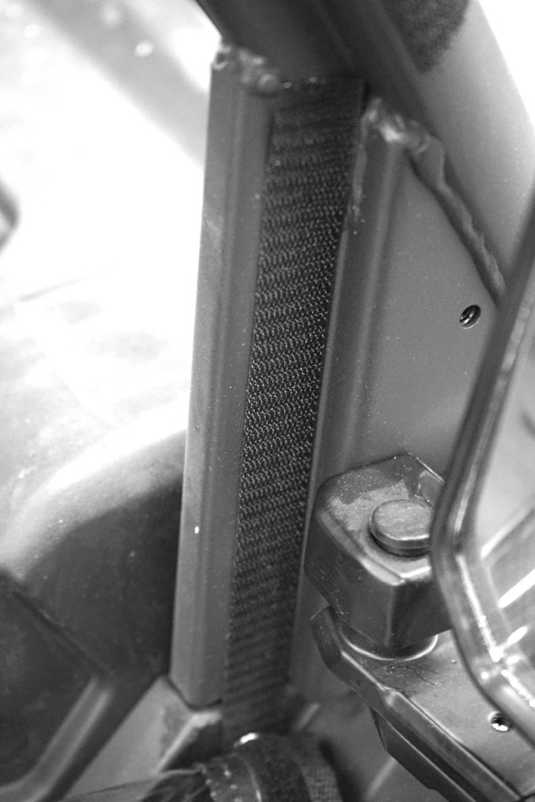

- Lastly install the snap studs into the plastic for the bottom portion of the door. It works best to put the screw studs into the snap sockets on the door first. Then one by one pull the door in place and push the screw into the plastic making sure to put enough pressure to leave a mark. Then remove the screw stud from the door and install it where the mark was left behind at. The following pictures show what it looks like.

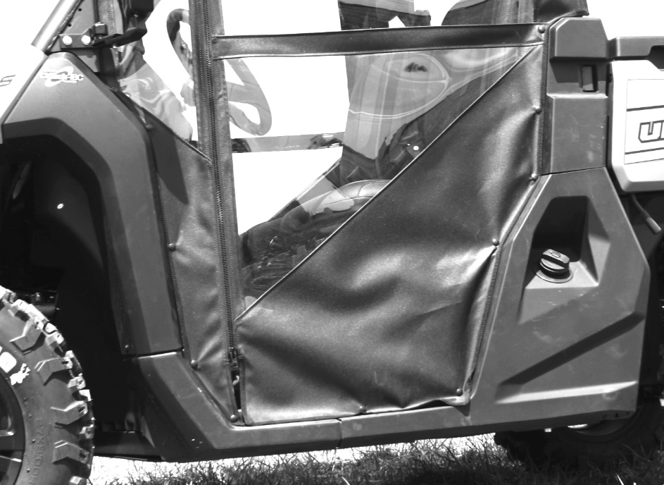

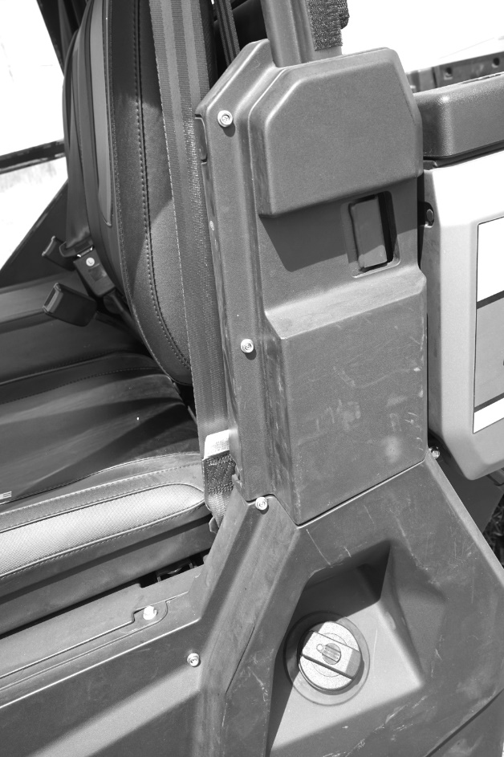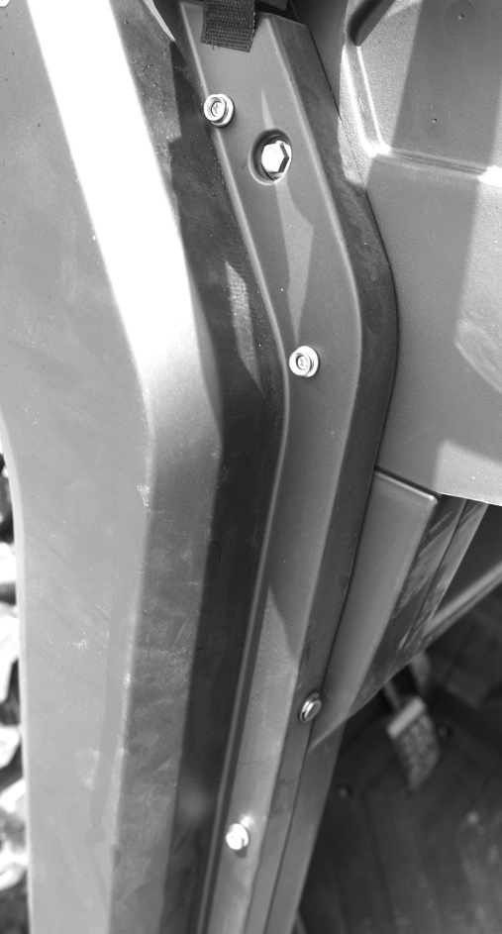

Cleaning and Storage Recommendations:
- Before removing the Cab for storage, make sure it is very clean in order to prevent scratching of the window panels. Clean with a soft rag or sponge using a mild liquid detergent soap and warm water solution. Never rub the windows with a dry cloth or rag! Let the Cab dry thoroughly before attempting to roll for storage.

- It is important that the Cab be rolled up for storage rather than folding. Folding will cause damage to the windows!!! Carefully roll up the Cab similar to the way it was when it was packed at the factory. On a large, clean and flat surface, fold the doors over the rear panel first, then, interleave the top and windshield on top of the doors. Begin rolling the Cab into a roll approximately 8 inches in diameter. Put the rolled Cab back into the carton for storage at a normal room temperature. It is best not to expose the Cab to either extreme hot or cold temperatures when storing.

If you have any questions, comments, need assistance, or are missing parts, please contact us by one of the methods below.

WARNING: This product contains a chemical known to the State of California to cause cancer. For more information, go to www.P65Warnings.ca.gov.

