
51-20995

Instructions for Installation and Care of Polaris 2014-2018 RZR 900s 1000s

& 1000xp & 19 RZR Soft Door Kit

CAUTION: Do not smoke inside the cab or expose the enclosure to direct flames. Product is FLAMMABLE.

Be sure to read these instructions thoroughly before opening and installing the enclosure. The installation is best done when ambient temperature is 70°F or warmer. If installed in cold weather, warming the adhesive Velcro strips before installation is recommended.

- Carefully open the carton and remove the rolled-up Cab Enclosure on a large flat surface that is clean and free of dirt or other material that may soil or scratch the windows of the Cab. Check over the parts included in the carton with the parts list shown below:

Velcro Hook strips:
Qty Length
2 15 inches
2 7 inches
18 3 inches

Snap Studs
Qty
22 (2 extra)

Door Panels
Qty
2 each

- Begin installation by hanging the Door Panels from the top by using the 3” adhesive Velcro strips as shown in the photos below and on the next page:

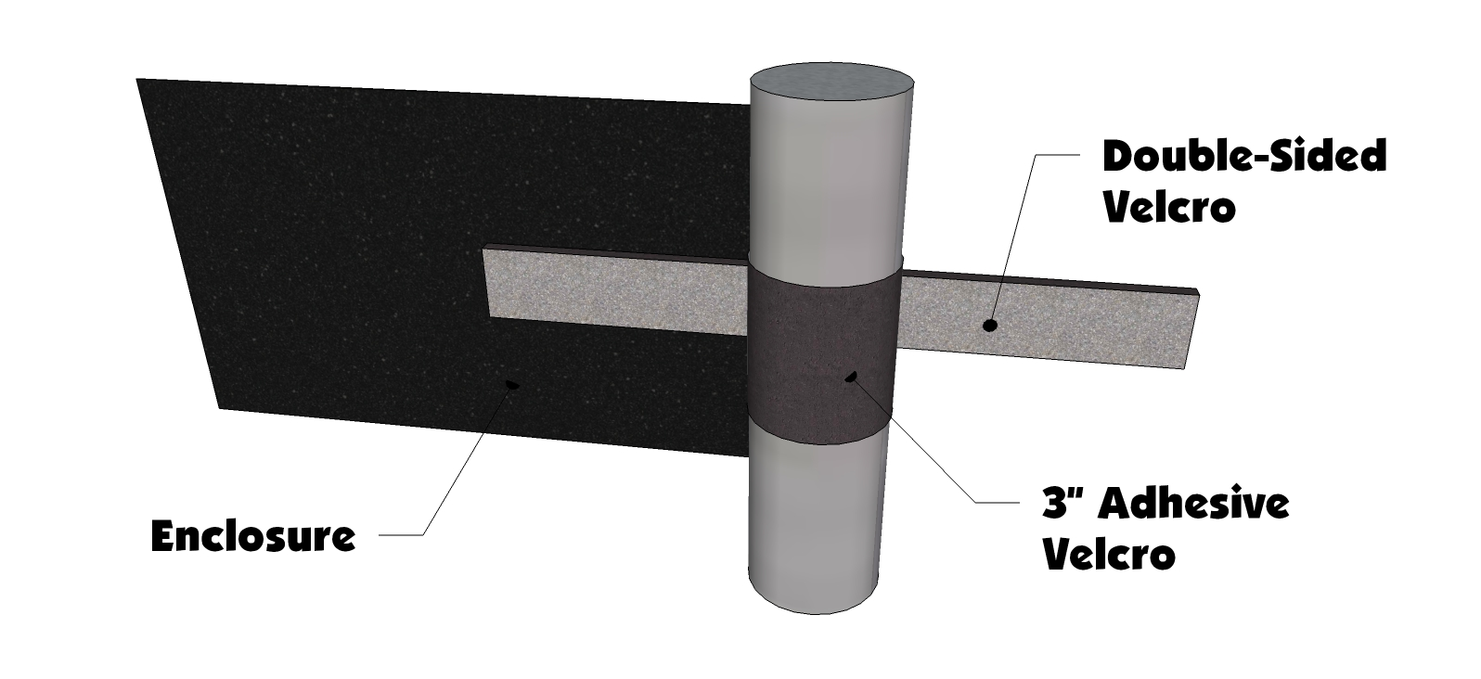

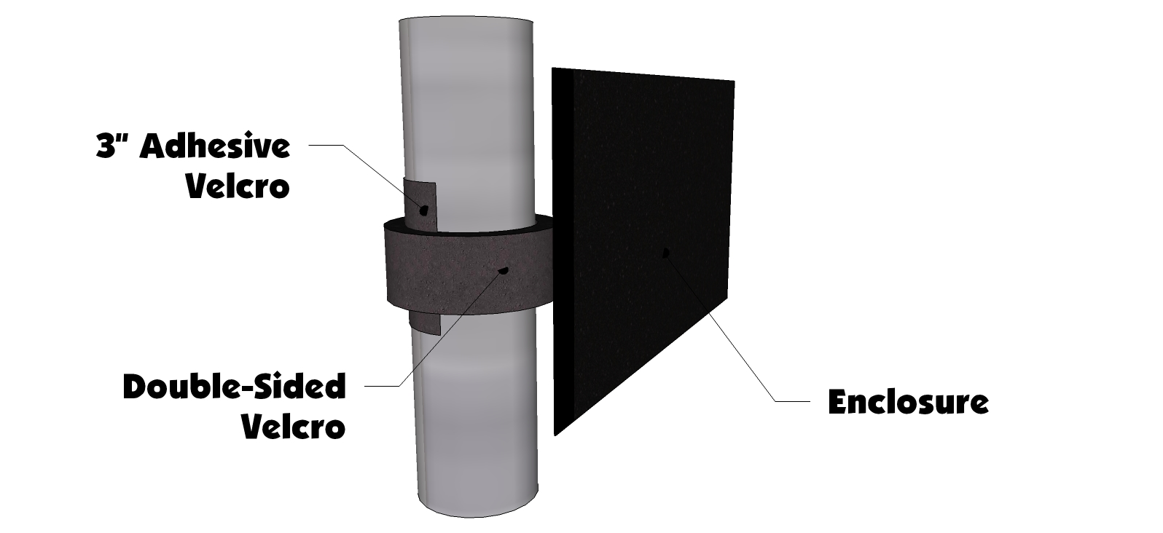
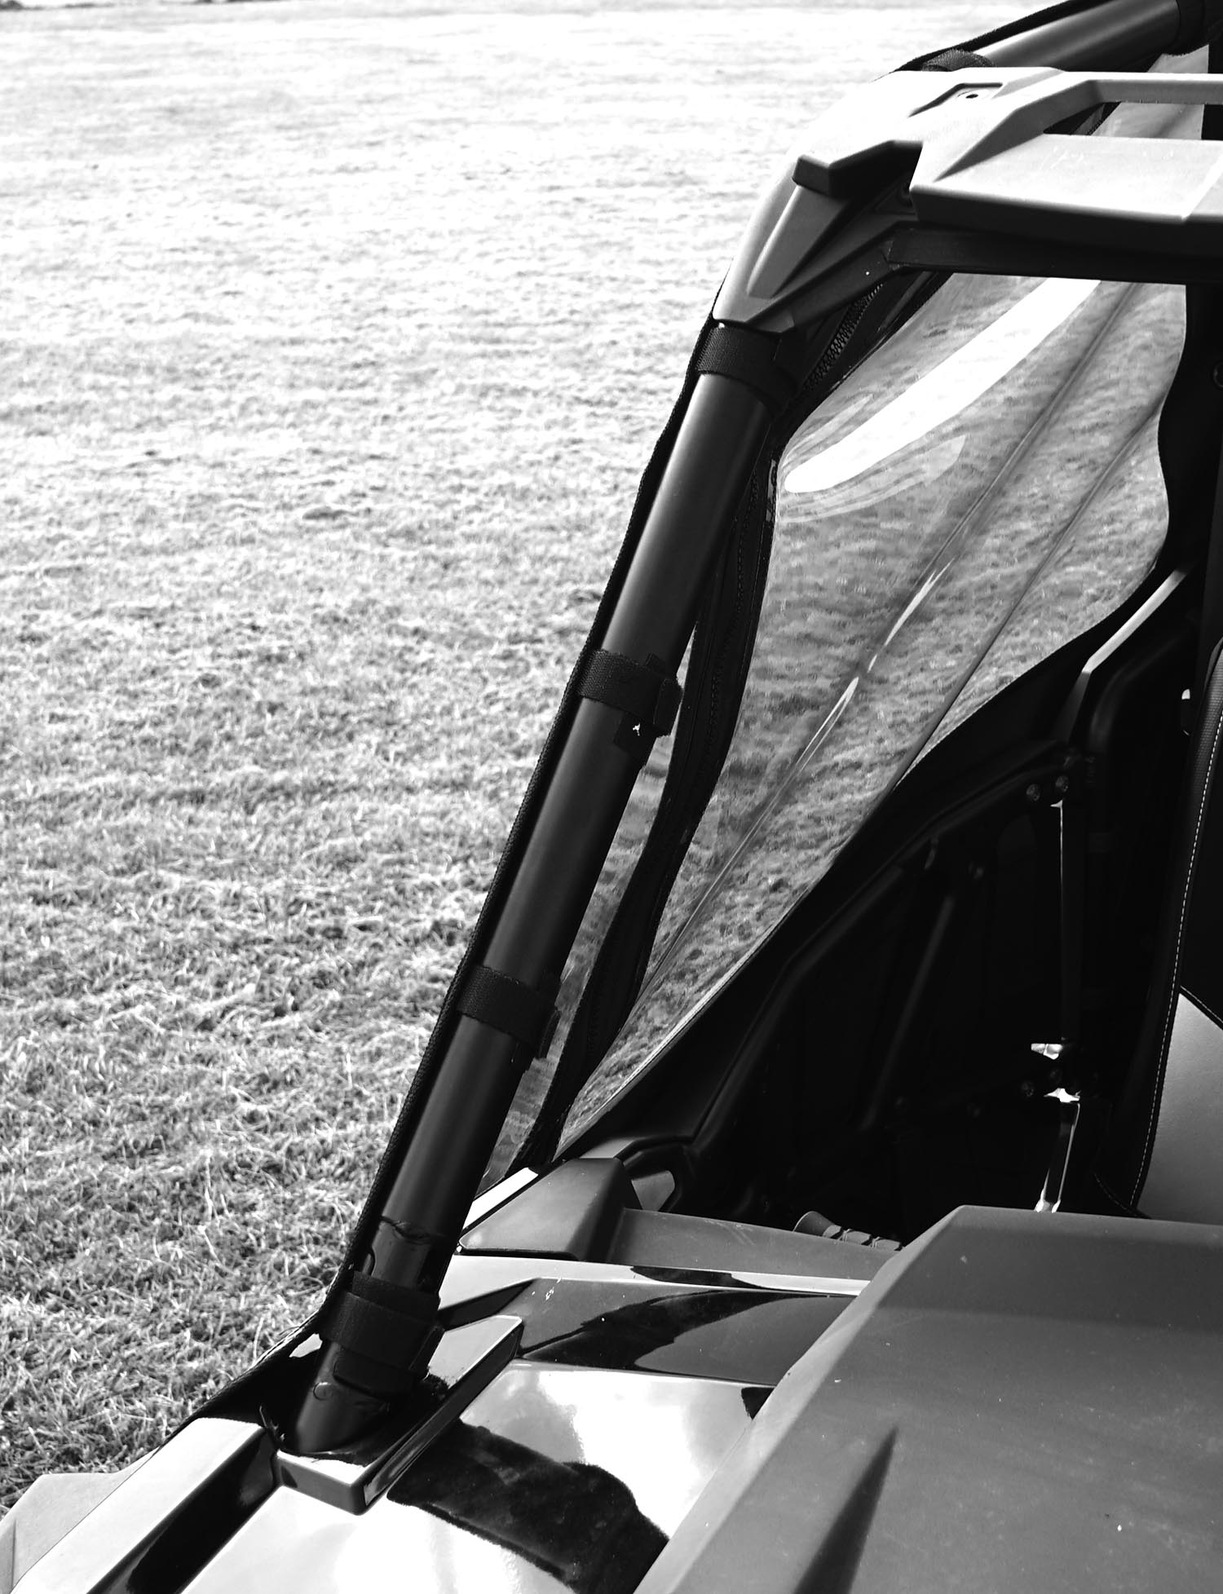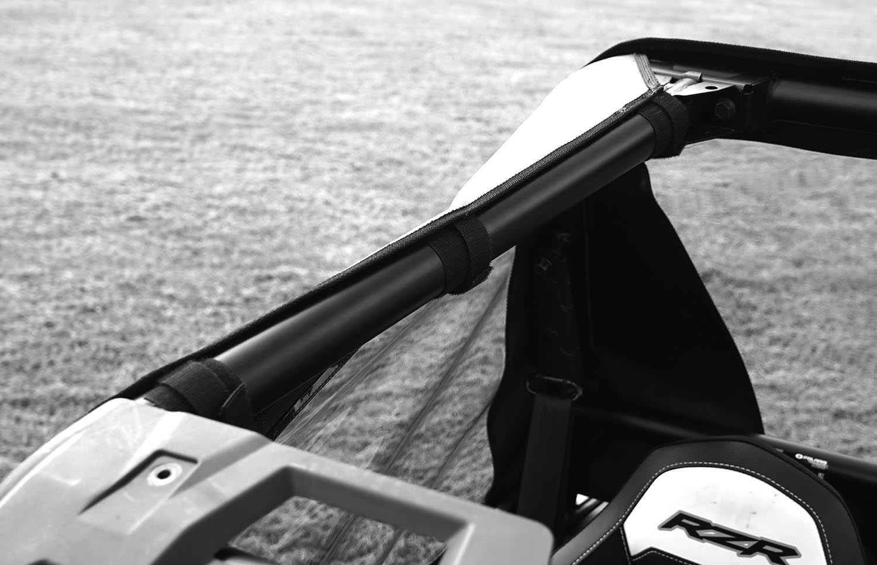

- After installing the double-sided strips move to the rear of the door and attach the two Velcro tabs to the rear bar using the corresponding adhesive Velcro strip. See Photo below:

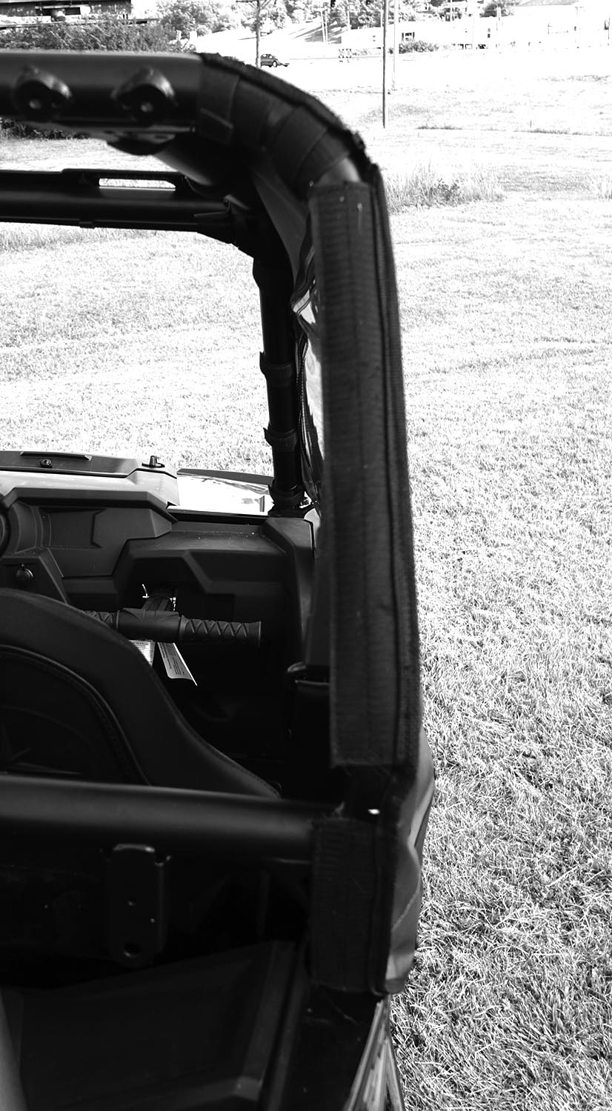
- Lastly snap the bottom of the door to the plastic doors on the RZR. NOTE: it helps to place the screw snaps into the sockets on the cabs first, then starting at the top one, push them into the plastic so a small dimple is left behind. Then pull the screw snap back out and screw it into the plastic where the mark was made. See photos below:

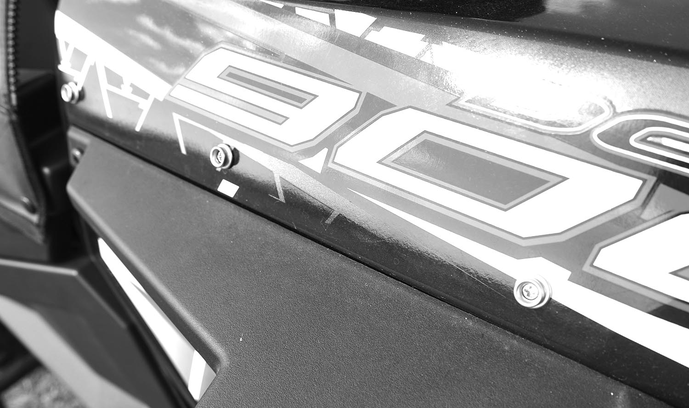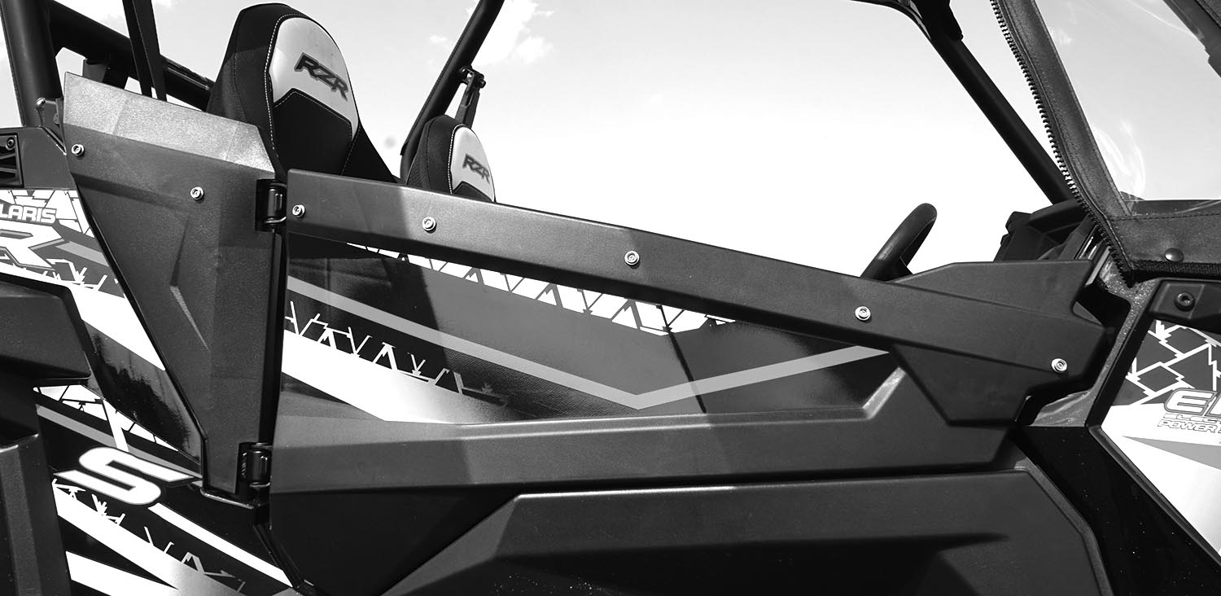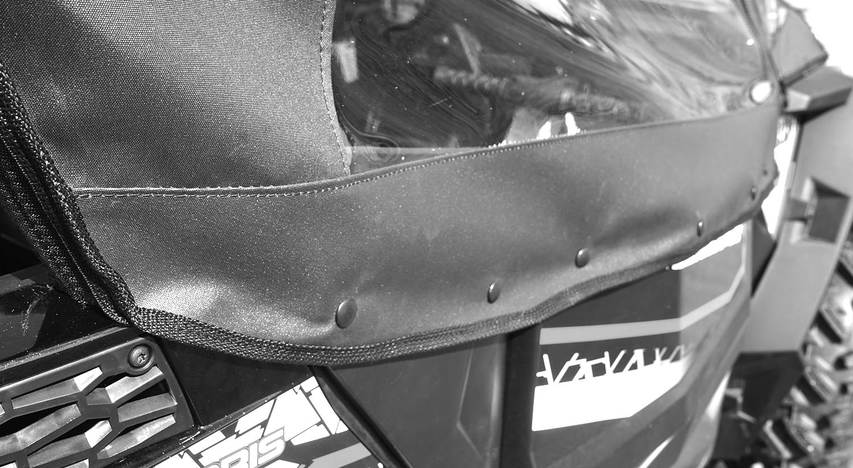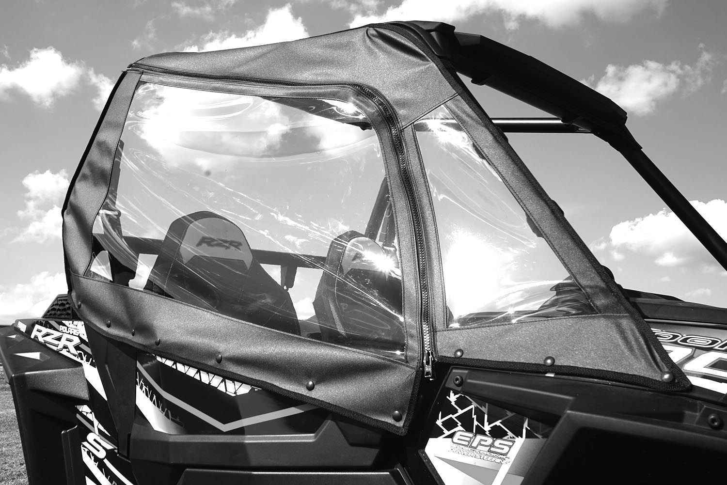

Cleaning and Storage Recommendations:

- Before removing the Cab for storage, make sure it is very clean to prevent scratching of the window panels. Clean with a soft rag or sponge using a mild liquid detergent soap and warm water solution. Never rub the windows with a dry cloth or rag! Let the Cab dry thoroughly before attempting to roll for storage.

- It is important that the Cab be rolled up for storage rather than folding. Folding will cause damage to the windows!!! Carefully roll up the Cab like the way it was when it was packed at the factory. On a large, clean, and flat surface, fold the doors over the rear panel first, then, interleave the top and windshield on top of the doors. Begin rolling the Cab into a roll approximately 8 inches in diameter. Put the rolled Cab back into the carton for storage at a normal room temperature. It is best not to expose the Cab to either extreme hot or cold temperatures when storing.

If you have any questions, comments, need assistance, or are missing parts, please contact us by one of the methods below.




WARNING: This product contains a chemical known to the State of California to cause cancer. For more information, go to www.P65Warnings.ca.gov.

